BRAC UNIVERSITY
Department of Computer Science & Engineering
Practice Problem sheet (Week7)
CSE 350: Digital Electronics and Pulse Technique

Question 1

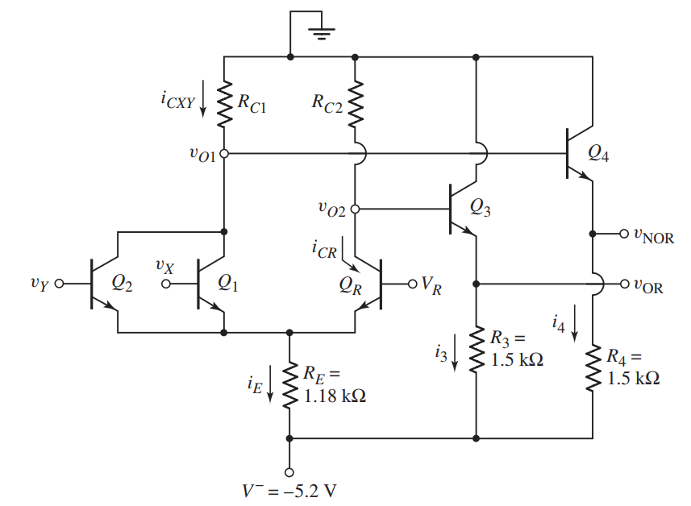
For the ECL logic circuit above, ignore the base currents and assume Reference voltage, V_{R} to be the average of logic high and logic low values. Also, assume when Q₁ and Q₂ are conducting, the B–C voltages of Q₁ and Q₂ are -0.1V.

(a) | Determine the logical low and high voltages for the circuit. Also, calculate the possible value of reference voltage, V_{R}.
(b) | Determine R_{C1} and R_{C2}.
(c) | Calculate the power dissipated in the circuit for the following cases:  (i) v_{x} = v_{y} = logic 1, and  (ii) v_{x} = v_{y} = logic 0.
Solution:
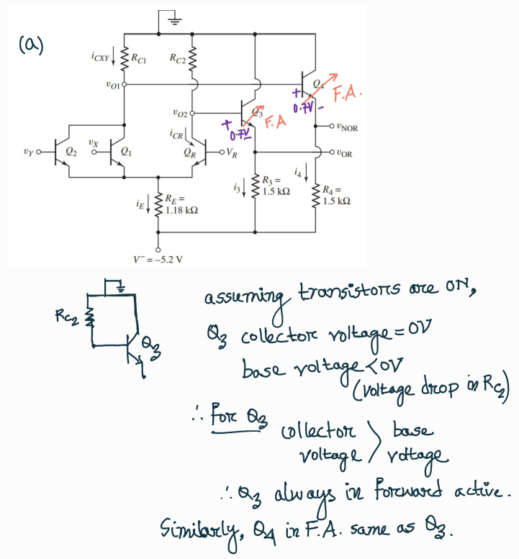
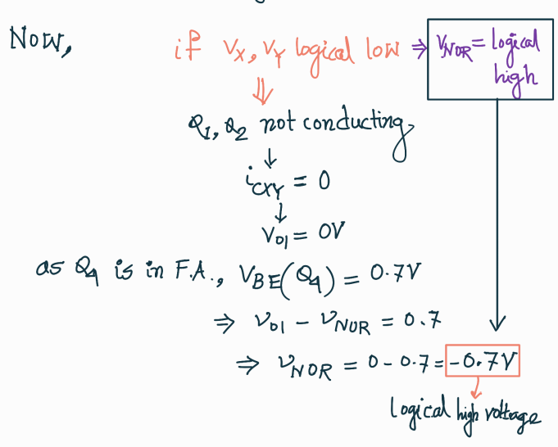
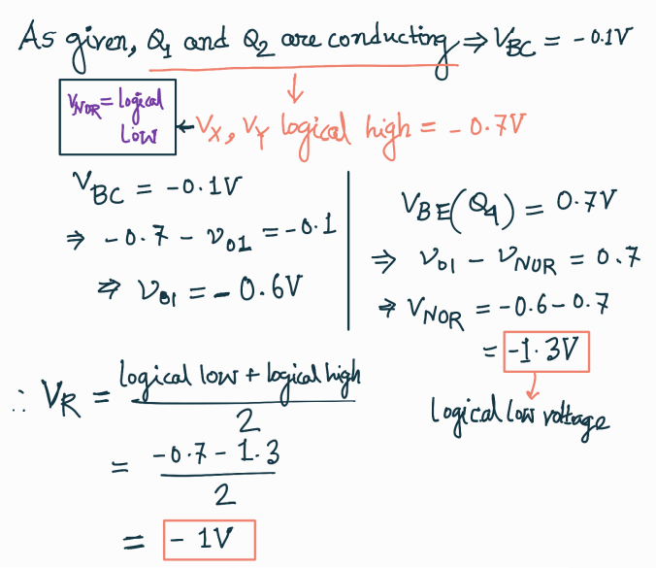
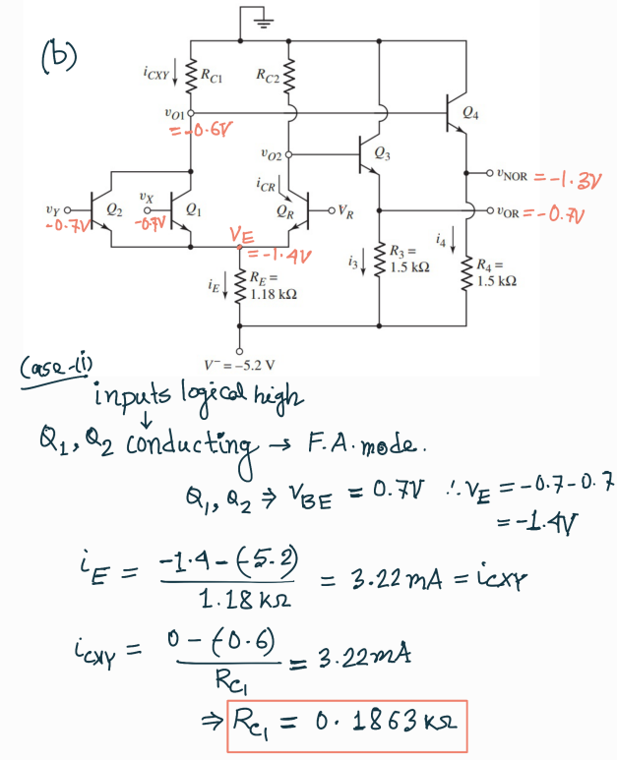
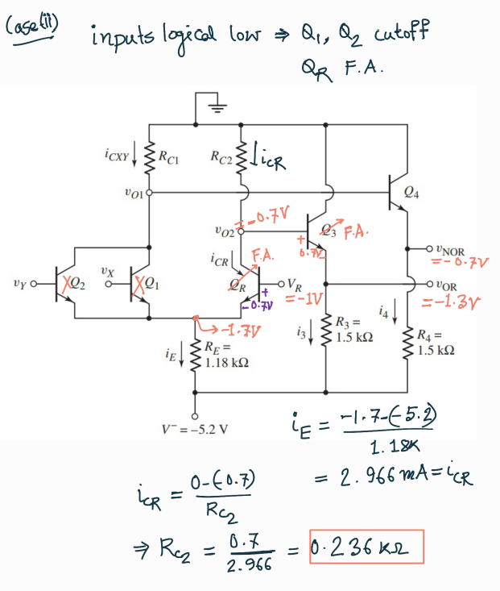
There is a mistake in the V_{O2} calculation above. For Q₃, V_{BE} = V_{O2} – V_{OR} = 0.7V
So, V_{O2} = 0.7 + (-1.3) = -0.6V

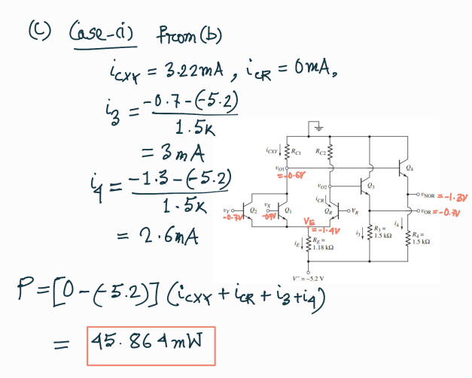
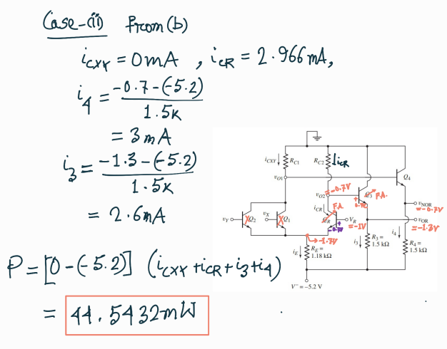

Question 2
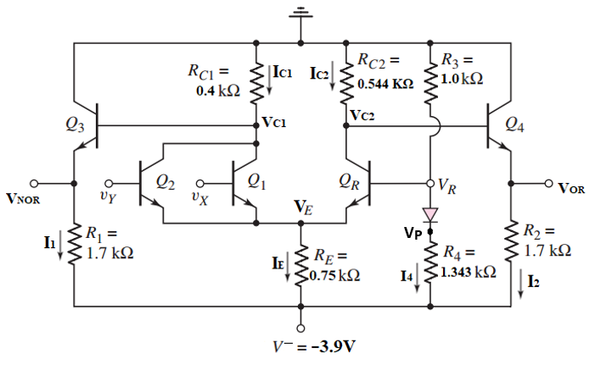
For the ECL OR/NOR circuit above, ignore the base currents and assume Reference voltage, VR to be the average of logic high and logic low values.

(a) | Determine the logic 0 and logic 1 voltage values for outputs V_{OR} and V_{NOR}.
(b) | When inputs V_{Y} and V_{x} are at Logical High, calculate V_{P}, I₁, I₂ and I₄.
(c) | Calculate the power dissipated in the circuit for the case mentioned in (b).
Solution:
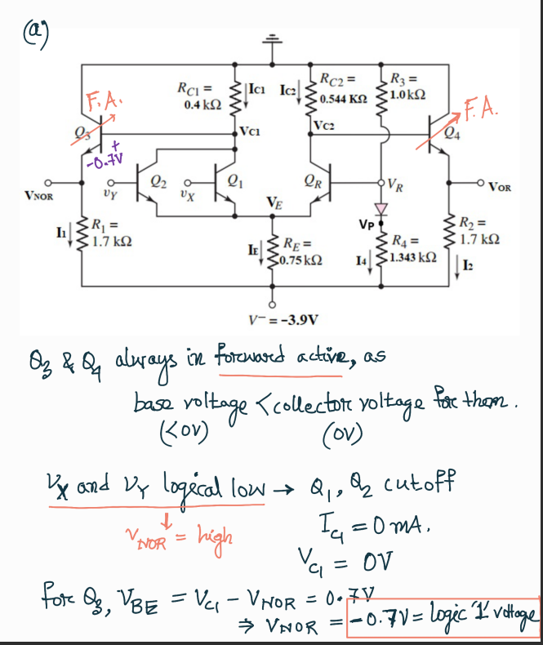
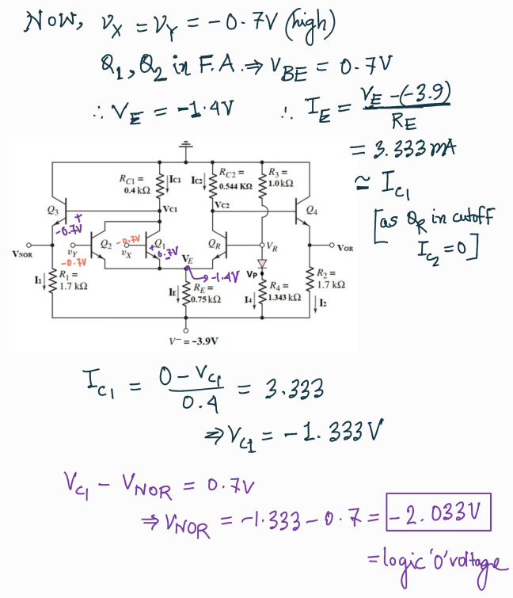
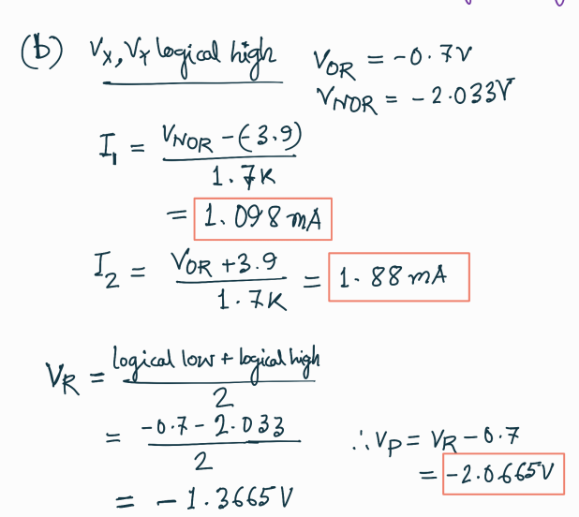
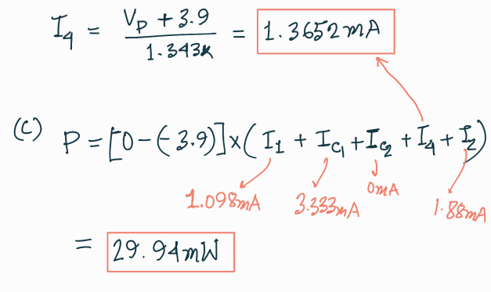

Question 3

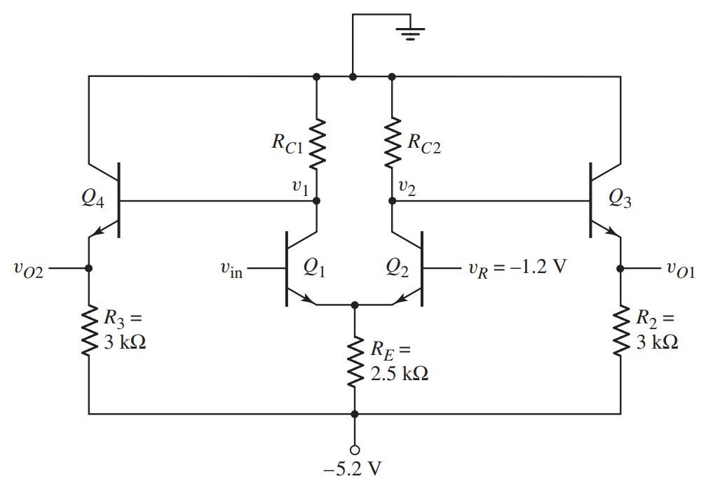
Consider the ECL circuit in the above figure. Ignore the base currents.

(a) | Determine R_{C2} such that v₂ = −1 V when Q₂ is on and Q₁ is off.
(b) | For v_{in} = −0.7, determine R_{C1} such that v₁ = −1 V.
(c) | Find v_{O1} and v_{O2} for (i) v_{in} = −0.7 V and (ii) v_{in} = −1.7 V.
(d) | Find the power dissipated in the circuit for both the cases mentioned in (c).

Solution:
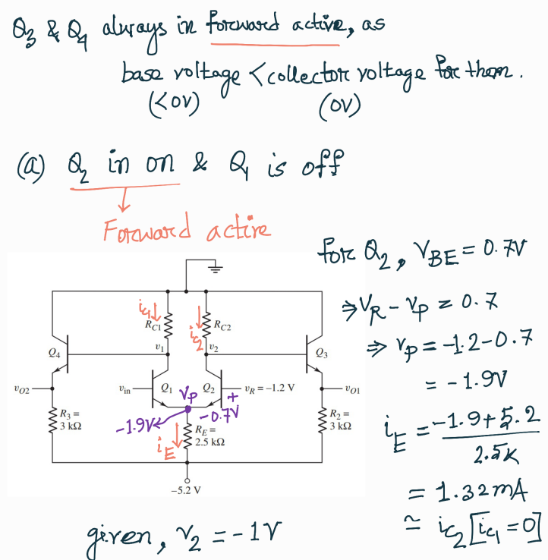
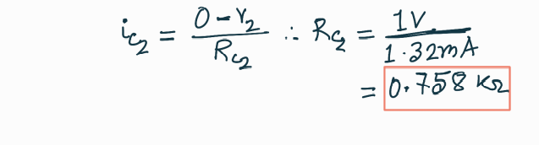
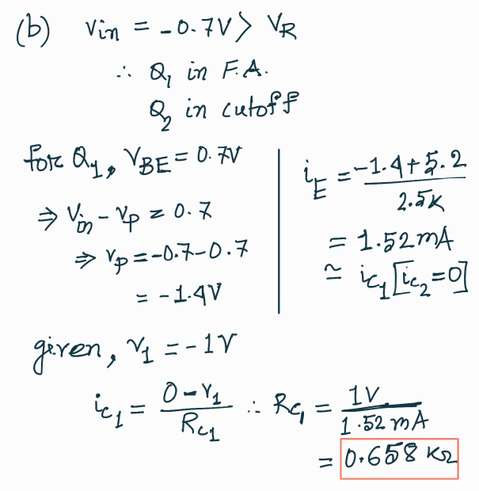
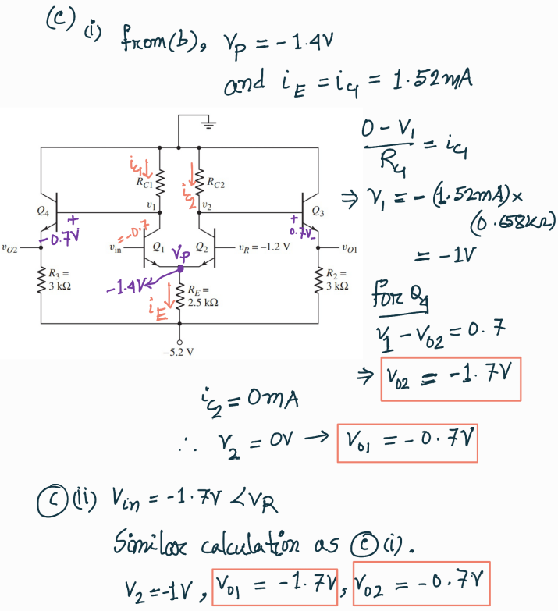
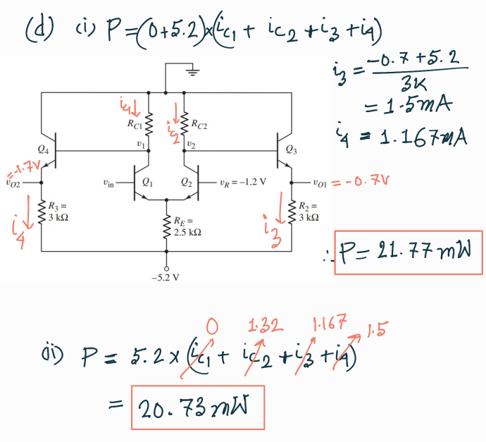

Question 4

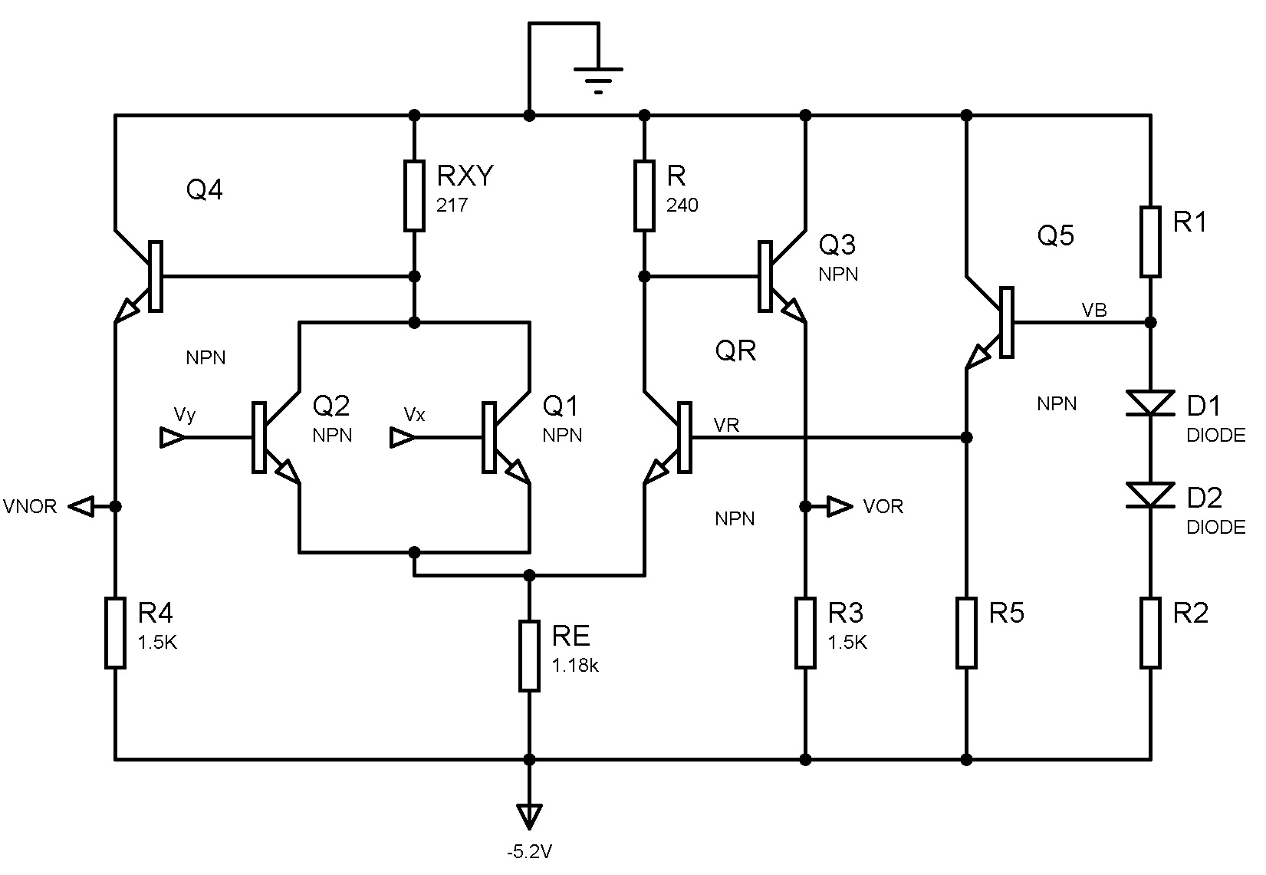
Consider the ECL circuit in the figure above, the logical high and low values are -0.7V and -1.4V respectively. Assume that the reference voltage VR is the average of the logical high and low values. Assuming transistor base currents are negligible, design the reference voltage generation circuit so that the currents through R5 and R2 are the same, and the reference voltage circuit power consumption is limited to 1mW. (Find the values of R1, R2 and R5)

Solution:
